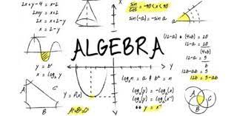

Algebra
Factorising, linear equations , simultaneous equations, quadratic equations

Factorising
- There are four main types of factorising : highest common factor , grouping , quadratic trinomials and difference of two squares.
- With quadratic trinomials , grouping and difference of two squares you should come out with two brackets in most cases.
- With HCF you should come out with something like : 5( 2x+3) , there can be numbers or letters before the bracket but there is never two brackets with this type of factorising .
- You do not have to solve for x when factorising .

Highest Common Factor
- Example : 5a+10
- First we have to look for the highest common factor between 5a and 10.
- In this case it would be 5 (5 goes into 5 and 10)
- We don’t write the (a) because there is no (a) with 10 , therefore it’s not a common factor.
- The answer is : 5(a+2)
- To know that you are right , you can multiply out your answer , it should be the same as the question.
- You can practise more of these on page 83 of Active maths 2.
Grouping
- From its name we know that we are grouping numbers together.
- We should end up with two brackets .
- Example : ax + 2bx + ay + 2by
- We know it’s grouping when we have four terms .
- First we have to rearrange the terms so that the first two terms have something in common and the second two terms have something in common , in this case it is already done for us.
- We will start with ax + 2bx since they’re the first two terms .
- We have to factorise them using the HCF method (last slide).
- We will end up with x(a+2b)
- We have to do the same with ay + 2by and we will end up with y(a+2b).
- We know that we’re correct when the numbers and letters in the brackets are the same in both equations .
- When we put them together we should have : x(a+2b)+y(a+2b).
- The last step is to put the numbers outside the brackets together so we have (x+y)(a+2b) as our final answer.
- You can practise more grouping on page 83 of active maths 2.

Difference of two Squares
- Difference of two squares is the most simple type of factorising .
- Example : x² - 4
- You have to make sure that there is a minus sign not plus first.
- Then you find the square root of both terms , in this case it’s x and 2.
- The next step is to draw out two sets of brackets , in one of them you’re going to write the first term minus the second term and in the second set of brackets you’re going to write the first term plus the second term.
- It should look something like (x-2)(x+2)
- Practise questions are on page 86 of active maths 2.

Quadratic trinomials
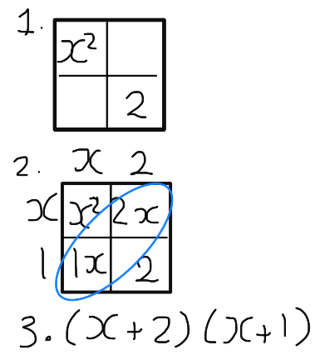
- We know it’s a quadratic trinomial when there are three terms including x² , x and a number (it can be any letter , doesn’t have to be x).
- Example : x² + 3x + 2
- We use the array model to solve this .
- We put the x² in the top left corner of the array model and the number in the bottom right corner (the remaining two should add up to the number in the middle) so it should look like:

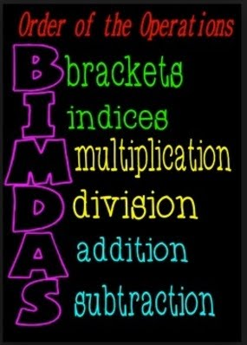
- Remember to use BIMDAS , especially when solving equations , it can help you solve many trick questions .
- If you don’t remember what BIMDAS is , here is a picture to remind you :

Linear Equations
- Linear equations are mainly about balancing an equation so we are bringing the letters to one side and numbers to the other side.
- It is important to remember that what we do to one side of the equation has to be done to the other side as well (If we take away a number on one side or add it has to be done on the other side as well)
- Example : 2x + 3 = 6 – x
- Our aim here is to bring the terms containing x to one and the numbers to the other side.
- I’m going to bring the x’s to the right side and the numbers to the left.
- We know that -1+1 will give us zero , this is the technique we’re going to use to get rid of the terms on one side and move it to the other.
- So we add the x on the right and add it again on the left .
- We then take away 3 on the left and do the same on the right.
- This leaves us with 3x = 3
- The next step is to get rid of the 3 that’s being multiplied by x , we simply divide 3x by 3 and do the same with the 3 .
- This gives us x = 1
- Go to page 165 for practise (active maths 2)

Simultaneous equations
- Simultaneous equations are when you are given two sums , with two unknown values , for example x and y.
- For short , you are using the two equations together to find the two values.
- Example : x + y = 4 x + 7y = 10
- It contains a lot of steps from previous equations , we first have to start off by making sure the x and y are on one side , while the number is on the other side .
- The next step is to try cancel out the x or y (whichever is easier)
- In this case it would be x , to get rid of it , we have to multiply the whole equation by -1 . (I multiplied the first sum)
- After getting rid of one of the letters , we just add or subtract the number and the other letter .
- At this point we should end up with : 6y = 6
- The next step is to get rid of the 6 , we do this by dividing it on both sides so we end up with y = 1
- We have to find out y next , we take any one of the previous equations , I’m going to use x + y = 4 , we just sub in 1 for y to find out x.
- We should end up with x = 3
- There are more practise questions on page 168 of active maths 2.

Quadratic Equations
- There are two ways to solve quadratic equations , the array model and the quadratic formula.
- We use the formula when we are told to round to a decimal point or when we are told to leave it in surd form.
- With both we have to make sure that the equation is in the form : x² + x + number = 0
- We have to make sure the equation is equal to zero before trying to solve it with the array model or formula.
- We should be getting two answers for x both ways.
- I will be solving an equation both ways on the next slide.
- P. 189 – 191 , active maths 2

Solving quadratic Equations
Array Model Quadratic formula

